BASE ALGO – INDICATOR 1

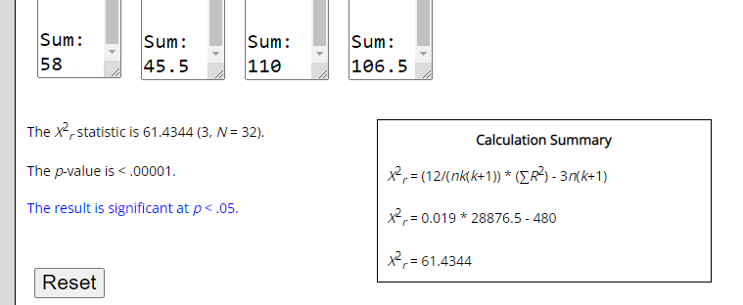

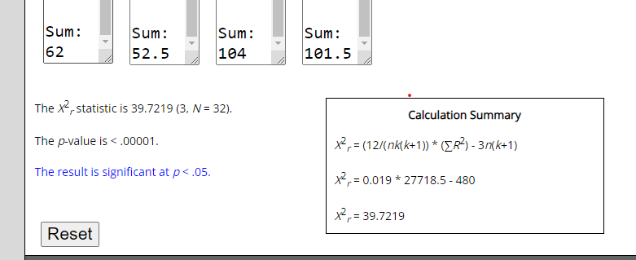HYBRIDS – INDICATOR 1

BASE ALGO – INDICATOR 2

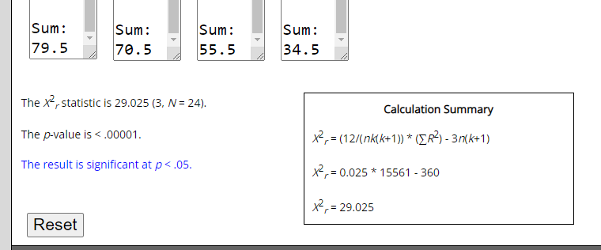

HYBRIDS – INDICATOR 2

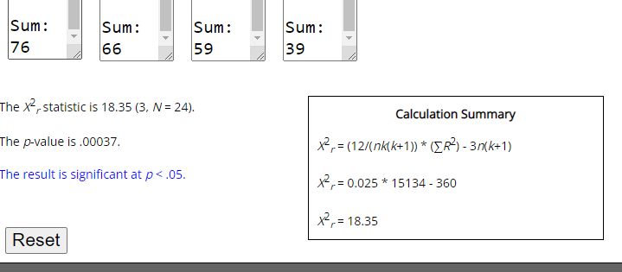

BASE ALGO – INDICATOR 3

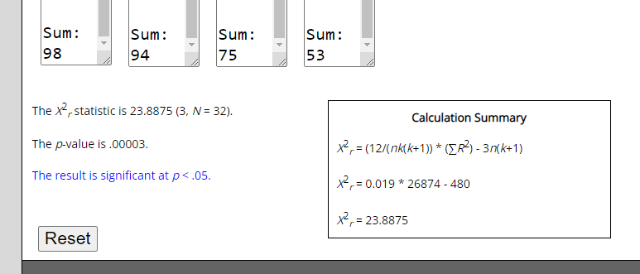

HYBRIDS – INDICATOR 3

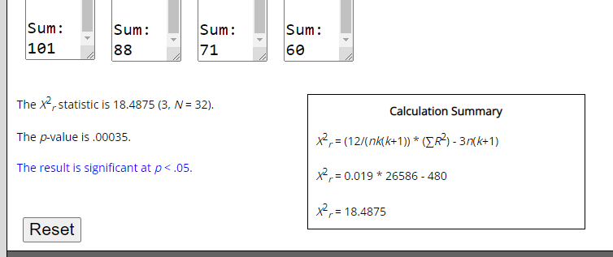

BASE ALGO – INDICATOR 4

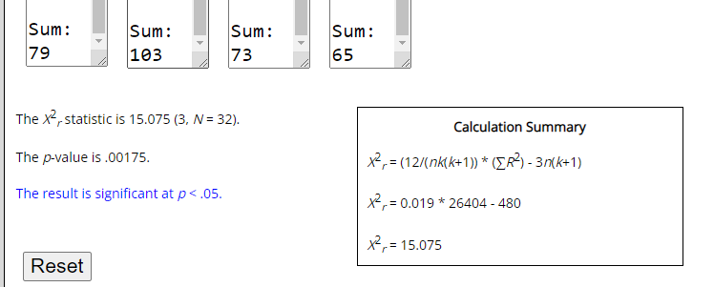

HYBRIDS – INDICATOR 4

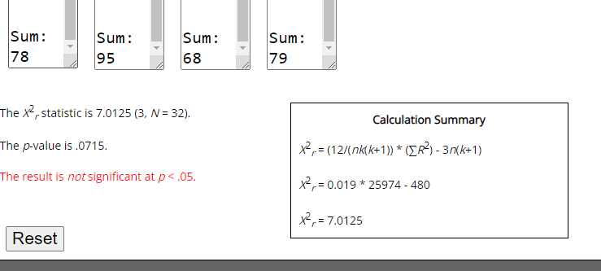

BASE ALGO – INDICATOR 5

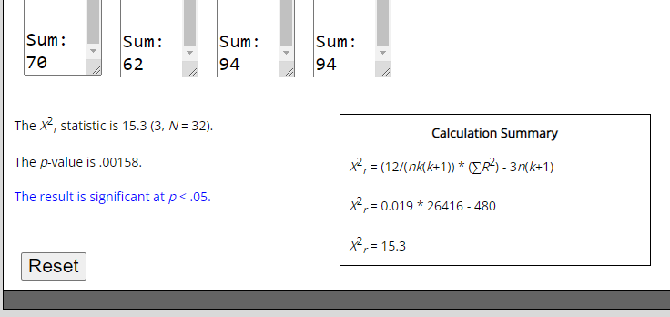

HYBRIDS – INDICATOR 5

